Click or tap here to enter text.

**TERM : FALL 2022**

| **Course & Section Code:** | **COMP214** |
| --- | --- |
| **Course Name:** | **Advanced Database Concept** |
|  |  |
| **Q&A / Virtual Office Hour:** |  |
| **Instructor Name & Email:** | Ersan Cam  [ecam@my.centennialcollege.ca](mailto:ecam@my.centennialcollege.ca) |

Assigment#3

(Database Programming Fundamentals)

**Due Date : Follow the announcement/ Assignment 3 drop box for Due date**

Instructions for delivery of this Labs file back to instructor.

**Step 1:** Download this word copy of Lab document.

**Step2:** Work on your question in SQL Developer.

**Step3:** Once you solve the problem copy paste the code under each question and Highlight with RED color

**Step4:** Also go to your Sql Developer and capture screen entire screen with command you execute and result at the bottom. Use Snipping tool in windows to capture screen shot. Below picture shows how to open free windows based snipping screen capture tool

Step5: Drop your finalized & saved word document to respective Lab dropbox assignment folder.

**Please note that Instructor has the right to call out any students randomly to ask demonstration their solution and walk thru their work and justify their answers in one on one breakout room.**

**The tool to capture screen shot.**

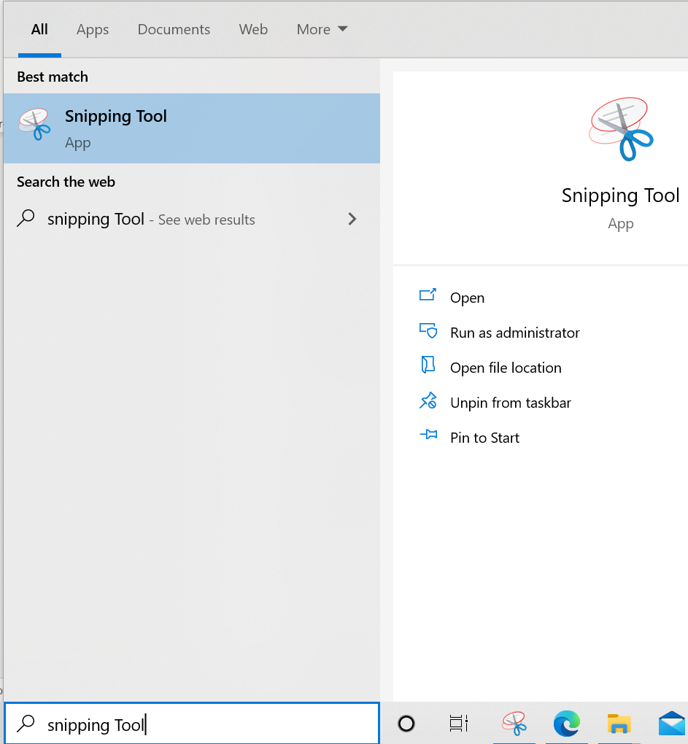

**Demo Question:** How to execute Sequence.Nextval command?

Demo Answer:

Copy paste of actual command: SELECT std_seq.NEXTVAL FROM DUAL;

Demo Screen shot:

Copy paste screen shot of same command

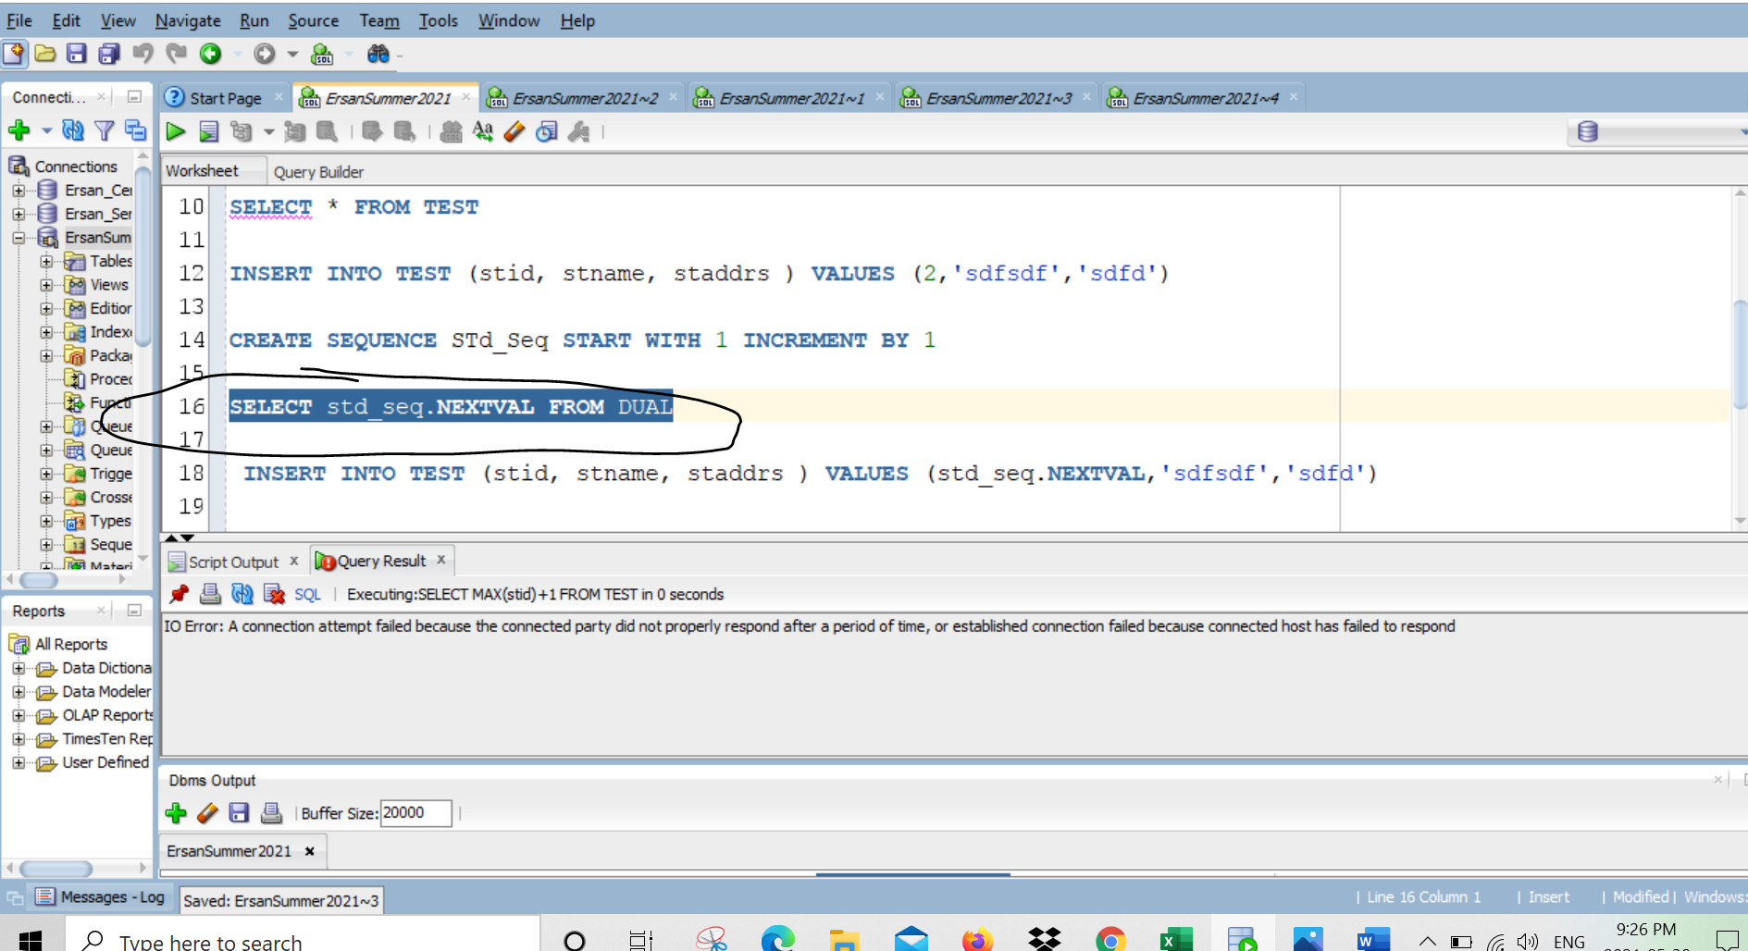

**Total 4 questions, each 2.5 points, Total 10**

Question 1 , 2 and 3 are from HR_ database tables

1)

CREATE or REPLACE PROCEDURE DEL_JOBS (p_job_id IN HR_JOBS.JOB_ID%TYPE)

IS

v_job_id HR_JOBS.JOB_ID%TYPE;

BEGIN

SELECT JOB_ID INTO v_job_id FROM HR_JOBS WHERE HR_JOBS.JOB_ID = p_job_id;

IF p_job_id = v_job_id THEN

DELETE FROM HR_JOBS WHERE HR_JOBS.JOB_ID = p_job_id;

END IF;

EXCEPTION

WHEN NO_DATA_FOUND THEN

RAISE_APPLICATION_ERROR (-20203,

'NO JOBS DELETED');

END DEL_JOBS;

**Testing DEL_JOBS Procedure**

SELECT * FROM HR_JOBS WHERE JOB_ID='IT_DBA';

EXECUTE DEL_JOBS('IT_DBA');

SELECT * FROM HR_JOBS WHERE JOB_ID='IT_DBA';

**Testing Exception**

EXECUTE DEL_JOBS('IT_WEB');

**2.** Create a PL/SQL block that selects the maximum department ID in the departments table and stores it in the v_max_deptno variable. Display the maximum department ID.

1. Declare a variable, **v_max_deptno** , of type NUMBER in the declarative section.
2. Start the executable section with the BEGIN keyword and include a SELECT statement to retrevive the maximum **department_id** from the departments table.
3. Display the **v_max_deptno** and end the executable block
4. Execute your code..

Output should be as follows

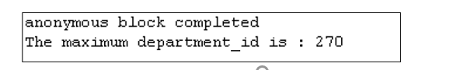

DECLARE

v_max_deptno NUMBER (8);

BEGIN

SELECT MAX(DEPARTMENT_ID) INTO v_max_deptno FROM HR_DEPARTMENTS;

DBMS_OUTPUT.PUT_LINE(' The maximum department_id is : ' || v_max_deptno);

END;

**3.** Modify the PL/SQL block you created in Question 2 to insert a new department in the departments table.

1. Use the same code that you completed in question 3 and edit it again to add below steps.

Declare two variales:

**v_dept_name** of type departments.department_name (%TYPE) and

**v_dept_id** of type NUMBER

Assign ‘Education’ to v_dept_name in the declarative section.

1. You have already retreived current maximum department ID from the departments tables in question 3. Now add 10 to it and assign the result to **v_dept_id**.
2. Include an INSERT statement to insert data into the department_name, department_id, and location_id columns of the departments table.

Use values in **v_dept_name** and **v_dept_id** for **department_name** and **department_id**, columns respectively and use NULL for **location_id**.

1. Use the SQL attribute SQL%ROWCOUNT to display the number of rows that are affected right after INSERT command.
2. Execute your script.

Output should be like follows.

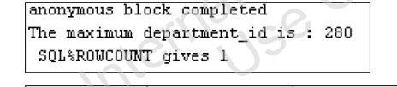

On different screen of SQL Developer, select Departments table and show newly added record

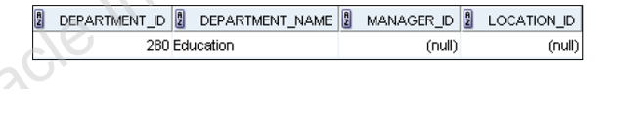

DECLARE

v_max_deptno NUMBER (8);

v_dept_name HR_DEPARTMENTS.department_name%TYPE := 'Education';

v_dept_id NUMBER (8);

BEGIN

SELECT MAX(DEPARTMENT_ID) INTO v_max_deptno FROM HR_DEPARTMENTS;

v_dept_id := v_max_deptno + 10;

INSERT INTO HR_DEPARTMENTS(department_name,department_id,location_id) VALUES(v_dept_name,v_dept_id,null);

SELECT MAX(DEPARTMENT_ID) INTO v_max_deptno FROM HR_DEPARTMENTS;

DBMS_OUTPUT.PUT_LINE(' The maximum department_id is : ' || v_max_deptno);

DBMS_OUTPUT.PUT_LINE(' SQL%ROWCOUNT gives '|| SQL%ROWCOUNT);

END;

For Question 4 Use BB Coffee Brewery database. BB_ tables

4. **Calculating a Shopper’s Total Number of Orders**

Another commonly used statistic in reports is the total number of orders a shopper has placed.

Follow these steps to create a function named NUM_PURCH_SF that accepts a shopper ID and

returns a shopper’s total number of orders. Use the function in a SELECT statement to display

the number of orders for shopper 23.

1. Develop and run a CREATE FUNCTION statement to create the **NUM_PURCH_SF** function.

The function code needs to tally the number of orders (using an Oracle built-in function)

by shopper. Keep in mind that the ORDERPLACED column contains a 1 if an order has

been placed.

2. Create a SELECT query by using the NUM_PURCH_SF function on the IDSHOPPER column

of the BB_SHOPPER table. Be sure to select only shopper 23.

**Hint:**

CREATE OR REPLACE FUNCTION

BEGIN

SELECT COUNT(idBasket)

INTO variable

FROM bb_basket

WHERE idShopper = p_id

AND orderplaced = 1;

RETURN variable;

END;

**Test:**

SELECT num_purch_sf(idShopper)

FROM bb_shopper

WHERE idShopper = 23;

**** CODE***

CREATE OR REPLACE FUNCTION NUM_PURCH_SF

(p_shopper_id IN BB_BASKET.IDSHOPPER%TYPE)

RETURN NUMBER IS

v_total_orders BB_BASKET.ORDERPLACED%TYPE;

BEGIN

SELECT COUNT(idBasket)

INTO v_total_orders

FROM BB_BASKET

WHERE idShopper = p_shopper_id

AND orderplaced = 1;

RETURN v_total_orders;

END NUM_PURCH_SF;

**Testing Function NUM_PURCH_SF**

SELECT NUM_PURCH_SF(idShopper)

FROM bb_shopper

WHERE idShopper = 23;

